

Monday, November 2, 2026 ALL SOULS DAY

8:00 a.m. Mass + For all the Souls

7:00 p.m. Mass + For all the Souls

Tuesday, November 3, 2026

8:00 a.m. + Alfredo Osmena -- Rod Yotingco & Leilani Osmena

Wednesday, November 4, 2026

8:00 a.m. + Bernice and Joseph Clarke – The Family

6:30 – 7:30 p.m. Adoration of the Blessed Sacrament

Thursday, November 5, 2026

8:00 a.m. + Martin Pandzich – Linda Pandzich

Friday, November 6, 2026

8:00 a.m. + Jose Moniz – Gloria Moniz

Saturday, November 7, 2026

5:00 p.m. For the Parish

Sunday, November 8, 2026

10:00 a.m. For the Parish

ARE YOU REGISTERED?
You may have been coming to St. Joseph Parish for many years and are not registered. We ask you to check with our parish office to make sure you are a registered parishioner. Parish registration is required to celebrate the Sacraments of Baptism, Confirmation, First Eucharist and Marriage.

STEWARDSHIP REPORT
We are grateful to all who contribute their time, talent and treasure to support our parish community and our mission. We continue to count on your generosity.

October 25, 2026
Sunday Offerings: $ 1,470.45
Maintenance: $ 230.00

POPE’S NOVEMBER PRAYER INTENTION
For the proper use of wealth – Let us pray for the proper use of wealth, that not succumbing to the temptation of selfishness, it may always be put at the service the common good and solidarity of those who have less.

GETTING MARRIED IN 2026-2027?
Couples planning on getting married at St. Joseph Parish this year or next are asked to contact the Parish Office as soon as possible to arrange a meeting with one of the priests. We look forward to celebrating with you.

COFFEE SUNDAY TODAY!


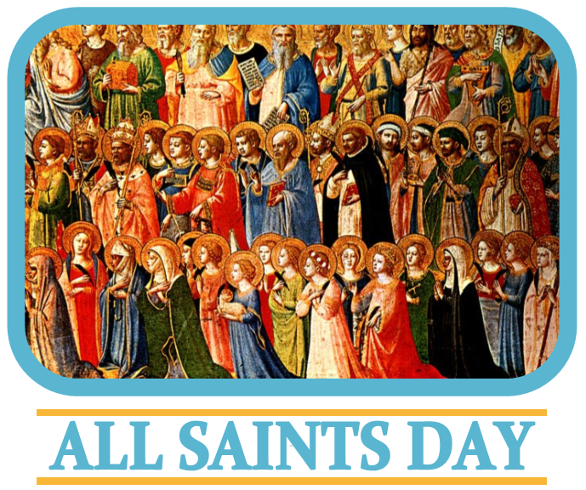

Next Sunday we will be celebrating the annual Solemnity of All Saints. The day is dedicated to the saints of the Church, that is, all those who have attained heaven. We also remember the millions, or even billions of people may already be saints, though they are not recognized in the canon of the saints by the Catholic Church. All Saints' Day was formally started by Pope Boniface IV, who consecrated the Pantheon at Rome to the Virgin Mary and all the Martyrs on May 13 in 609 AD. (Boniface IV also established All Souls' Day, which follows All Saints.) The holy day was eventually established on November 1 by Pope Gregory III in the mid-eighth century as a day dedicated to the saints and their relics. The May 13 celebration was subsequently abandoned.

Today, the usual Prayers of the faithful will be replaced by the Litany of the Saints, as we seek their intercession for our needs and the needs of the world.

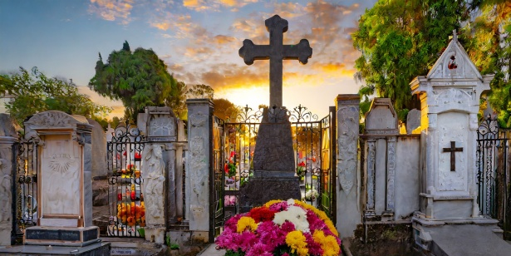

ALL SOULS DAY
Commemoration of the Faithful Departed
On this day we pray for all those who have gone before us in death, all who were signed with the Cross of Christ in Baptism, shared in the death and Resurrection of Christ and have been called home to the Father’s house.

Eternal rest, grant unto them, O Lord,
and let perpetual light shine upon them.
May their souls and the souls of all the faithful departed
rest in the peace of Christ.
THE BOOK OF LIFE
During the month of November, we will prayerfully remember all those who have gone before us in death. Those whose names are written in the Book of Life located by the Easter Candle will be remembered at every Mass celebrated in our Parish during this month.

PREPARATION FOR FIRST RECONCILIATION
PARENT MEETING November 3, 2026
Children preparing for First Communion (after Easter) are prepared also to celebrate this Sacrament of God’s mercy and forgiveness and given the opportunity to celebrate this Sacrament prior to First Communion. program.
Parents are invited to participate in an information meeting in the Parish Hall on Tuesday, November 3, 2026, at 6:30 p.m. Resources will be provided to assist the parents in the immediate preparation of their children for this Sacrament of God’s mercy.
The reception of First Reconciliation will take place on Tuesday, December 1, 2026, at 6:30 p.m. in the church.

DISCOVERING NEW PATHS
FOR YOUR MARRIED LIFE

Healthy marriages matter and marriage enrichment helps keep them strong! Proven benefits include having a support system, learning to grow together, having increased happiness levels and better physical health; all proven in research! Keeping your marriage healthy and strong requires love, but also time spent fine tuning your relationship and reconnecting. Join us on Saturday, November 21st at St. Thomas the Apostle Parish in Waterdown for a day to reconnect, discover new ways to deepen your relationship and spend time with the one you love! Registration can be found online at hamiltondiocese.com, by looking for the date under Upcoming Events, or contact Sarah at 905-528-7988 ext. 2249, or e-mail familyministry@hamiltondiocese.com

MEN’S DISCERNMENT GROUP
Fr. John Ha, our Vocations Director, invites all young men in the Diocese of Hamilton to join the Priesthood Discernment Group. Come for prayer, fellowship, and conversation as we explore God’s call together. Whether you are just beginning to ask questions or have been considering the priesthood for some time, you are welcome. Feel free to invite a friend who may be interested. You do not need to have all the answers—simply come with an open heart. Meeting in Hamilton on Friday, November 6, 2026, at 6:00pm at the Chancery Office (700 King St W, Hamilton, ON L8P 1C7) Sponsored by the Vocations Office of the Diocese of Hamilton. Visit hamiltondiocese.com/vocations. For more information, contact vocations@hamiltondiocese.com

WALK WITH JESUS:
A Retreat Day for Parents Who Have Experienced the Death of a Child – The loss of a child is a most challenging event in the life of any parent. This grief is acute and challenging. The Diocese of Hamilton invites you to join us for this healing day. Whether the loss is recent or some time ago, we know this day will help to restore your inner peace. The retreat will be offered from 9:00am to 4:00pm on Saturday, November 7th at St. Catherine of Siena Parish in Hamilton. The $20 fee includes lunch. Registration is required so we can plan for handouts and food. You can register on the Diocesan home page at hamiltondiocese.com under upcoming events (look for the retreat date), or by calling the office at 905-528-7988 ext. 2249.



Let us pray…
For vocations to the priesthood and religious life:
that example and prayers of the saints may inspire young people to seek holiness and offer their lives generously in the service of Christ.

PARISH BAZAAR
Saturday, November 21, 2026
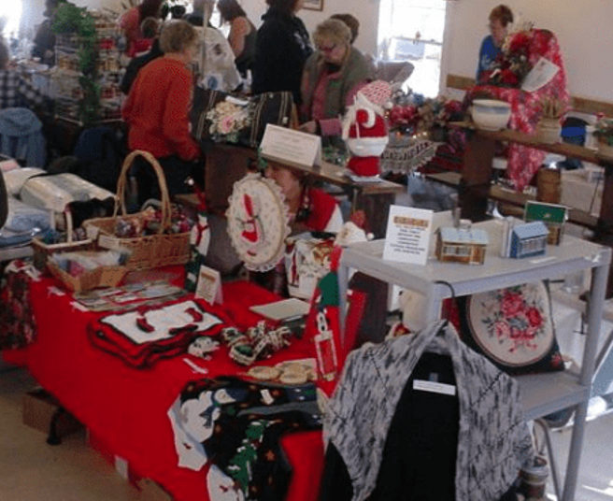

50/50 tickets are available now, See a bazaar member or the parish office. Thanks so much for supporting this major fundraiser for our parish! Contact Colleen Francisci for more info Text 289-556-6681 or ctfrancisci@hotmail.com

Is Canada on Track for Justice?
This fall, Development and Peace — Caritas Canada (DPCC) encourages you to call on the Government of Canada to increase funding for official development assistance. The world is facing multiple crises, and aid for impoverished countries is becoming increasingly scarce. Together, let’s make international solidarity a priority!

