

Tuesday, October 20, 2026

8:00 a.m. + Nick Ramacieri – The Sager Family

Wednesday, October 21, 2026

8:00 a.m. + Eduarda Barbosa & husband – Gloria Moniz

Thursday, October 22, 2026

8:00 a.m. + Daniella Conz – Renzo & Family

Friday, October 23, 2026

8:00 a.m. + Jeffrey Toole – Rosalie Little

Saturday, October 24, 2026

5:00 p.m. For the Parish

Sunday, October 25, 2026

10:00 a.m. For the Parish

ARE YOU REGISTERED?
You may have been coming to St. Joseph Parish for many years and are not registered. We ask you to check with our parish office to make sure you are a registered parishioner. Parish registration is required to celebrate the Sacraments of Baptism, Confirmation, First Eucharist and Marriage.

STEWARDSHIP REPORT
We are grateful to all who contribute their time, talent and treasure to support our parish community and our mission. We continue to count on your generosity.

October 11, 2026
Sunday Offerings: $1,258.50

POPE’S OCTOBER PRAYER INTENTION
For mental health ministry – Let us pray that the mental health ministry be established throughout the Church, helping to overcome the stigma and discrimination of persons with mental illness.

GETTING MARRIED IN 2026-2027?
Couples planning on getting married at St. Joseph Parish this year or next are asked to contact the Parish Office as soon as possible to arrange a meeting with one of the priests. We look forward to celebrating with you.

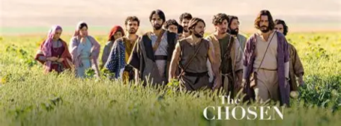

The Chosen Season 3 Study Group is Monday evening in the Parish Hall from 6:15 – 8:15 p.m. All are welcome.
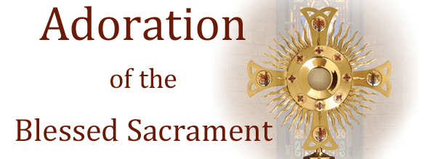

Join us on Wednesday evenings from 6:30 – 7:30 p.m. for an hour of silent prayer in the presence of Christ, the Bread of Life. This is a longstanding devotional practice which leads us to deepen our union with Christ.

PARISH BAZAAR
Saturday, November 21, 2026
We are seeking donations of New items, gift cards, or bottles for the raffles. Gently used items for Attic treasures— no clothing, religious items (statues, sculptures, crucifixes, rosaries, scapulars, bookmarks, devotional items, prayer books and bibles), Books—no encyclopedias or magazines, Kids’ toys and games, Plants/art/Christmas ornaments Crafts/knitting Jams/jellies Baked goods— we will need these for the day of the bazaar.

50/50 tickets are available now, See a bazaar member or the parish office.

Thanks so much for supporting this major fundraiser for our parish! Contact Colleen Francisci for more info Text 289-556-6681 or ctfrancisci@hotmail.com

WORLD MISSION SUNDAY
“One in Christ, united in mission” Today the whole Catholic world keeps the 100th World Mission Sunday. The psalm sings, “Tell his glory among the nations” (Ps 96). Pope Leo XIV reminds us that no baptized person is exempt from mission, and that if unity is the condition of mission, love is its essence. A second collection is taken up today for the Society for the Propagation of the Faith. Your gift, joined to those of Catholics everywhere, supports seminarians, catechists, chapels, healthcare, and the poor in young Churches. Pray also for new missionary vocations. Father, make us one in Christ, united in mission. Amen.

AN Autumn Prayer
“Heavenly Father, thank you for being the God of the seasons. As we experience a new touch of coolness in the air and adjust to the earlier setting of the sun, we are reminded that you change the seasons of our lives as well.

Help us to trust you in our empty seasons as well as our full seasons. Help us to experience your love and goodness in the seasons of abundance as well as the seasons of scarcity. Amen.”
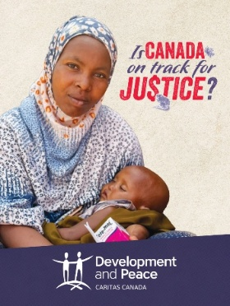
Do you believe in the dignity of the human person? For Development and Peace — Caritas Canada, this Catholic social justice principle is at the heart of our work. With the support of the government and generous donors, we carry out transformative programs and projects in more than 30 countries around the world.
This aid is invaluable—and even lifesaving—for many impoverished communities. It can help save children’s lives in Somalia through treatments for malnutrition and promote gender equality and women’s civic participation in the Democratic Republic of Congo.
We need your support to make this possible. The more members we have, the stronger our voice is as we call out for justice. Join the movement today! To learn more: devp.org/campaign.



The Month of October is dedicated to prayer for priestly vocations in the Diocese of Hamilton.
Let us pray…

For vocations to the priesthood and marriage: that Christ may raise up priests and married couples who share the Gospel through their words, hospitality, and faithful love, bringing hope to those who do not yet know him.

MEN DISCERNMENT GROUP
Fr. John Ha, our Vocations Director, invites all young men in the Diocese of Hamilton to join the Priesthood Discernment Group. Come for prayer, fellowship, and conversation as we explore God’s call together. Whether you are just beginning to ask questions or have been considering the priesthood for some time, you are welcome. Feel free to invite a friend who may be interested. You do not need to have all the answers—simply come with an open heart. Meeting in Hamilton on Friday, November 6, 2026, at 6:00pm at the Chancery Office (700 King St W, Hamilton, ON L8P 1C7). Sponsored by the Vocations Office of the Diocese of Hamilton. Visit hamiltondiocese.com/vocations. For more information, contact vocations@hamiltondiocese.com.

PARISH FINANCE COUNCIL
The Parish Finance Council will meet on Thursday evening (October 22nd) at 7:00 p.m. in the Upper Rectory Meeting Room.
DISCOVERING NEW PATHS
FOR YOUR MARRIED LIFE

Healthy marriages matter and marriage enrichment helps keep them strong! Proven benefits include having a support system, learning to grow together, having increased happiness levels and better physical health; all proven in research! Keeping your marriage healthy and strong requires love, but also time spent fine tuning your relationship and reconnecting. Join us on Saturday, November 21st at St. Thomas the Apostle Parish in Waterdown for a day to reconnect, discover new ways to deepen your relationship and spend time with the one you love! Registration can be found online at hamiltondiocese.com, by looking for the date under Upcoming Events, or contact Sarah at 905-528-7988 ext. 2249, or e-mail familyministry@hamiltondiocese.com

NEIGHBOURS IN NEED UPDATE
Parish donations no longer cover the cost of providing PC grocery cards every month the approximately 60 singles and families who we support through our Neighbours in Need Program. Between January and August of this year, donations totaled $6,600, which averages $825 per month available to buy grocery cards. Even after we reduced what we give to a minimal $25 per month for singles and $35 per month for families, that works out to an average of $1450 each month. This is almost double what we received in donations.

As a result, we can only afford to provide grocery cards every second month starting in 2027.

We will again request extra grocery cards from parishioners for Christmas, and based on previous years, every recipient will receive $75 or more, to buy extra Christmas groceries.

This program has been helping people who live within the boundaries of St. Joseph Parish for over 25 years, and we are determined to keep it going as long as possible. Our recipients continue to thank us for the little we can afford to give, because every little bit helps.

WALK WITH JESUS:
A Retreat Day for Parents Who Have Experienced the Death of a Child – The loss of a child is a most challenging event in the life of any parent. This grief is acute and challenging. The Diocese of Hamilton invites you to join us for this healing day. Whether the loss is recent or some time ago, we know this day will help to restore your inner peace. The retreat will be offered from 9:00am to 4:00pm on Saturday, November 7th at St. Catherine of Siena Parish in Hamilton. The $20 fee includes lunch. Registration is required so we can plan for handouts and food. You can register on the Diocesan home page at hamiltondiocese.com under upcoming events (look for the retreat date), or by calling the office at 905-528-7988 ext. 2249.

